ASSIGNMENT – 1
System Design — Movie Ticket Booking System
Course: B.Tech. CSE | Semester: 5
Subject: System Design | Subject Code: TCS-504
Submission Date: 07-September-2026

Submitted By: Yash Diwakar
Roll No.: 2419152
Student ID: 240111970
Section: G1
Submitted To: Mr. Himanshu Namdev Sir

A. Requirement Analysis

Functional Requirements
FR1 — Movie Listing: The system shall display all movies currently playing along with their title, language and duration.
FR2 — Show Listing: For a selected movie, the system shall display its available shows with screen number and start time.
FR3 — Seat Display: For a selected show, the system shall display the seat layout and indicate each seat as AVAILABLE or BOOKED.
FR4 — Booking: A customer can select one or more seats. If any selected seat is already BOOKED, the booking is rejected and no seat state changes. Booking is confirmed only after successful payment.
FR5 — Pricing: The system shall calculate the total amount using seat type: SILVER ₹150, GOLD ₹250 and PLATINUM ₹400.
FR6 — Payment: Exactly one payment method (UPI, Card or Cash) is selected per booking. A failed payment must not confirm the booking and the selected seats remain available.
FR7 — Ticket: After successful payment, the system shall print a ticket containing booking ID, movie, screen, time, seat numbers and total amount.
FR8 — Cancellation: A customer can cancel a confirmed booking, after which all seats in that booking become AVAILABLE again.

Non-Functional Requirements
- Modularity — each major class is maintained in a separate source file and modules have focused responsibilities.
- Extensibility — new payment methods can be introduced through the Payment abstraction without changing the existing payment classes.
- Reliability — failed payments do not confirm bookings and cancelled bookings release their seats.
- Input Validation — invalid menu choices, show indexes and seat numbers are handled with clear messages without crashing.

B. Noun–Verb Analysis
Noun found | Class? | Reason
Movie | Yes | Own data and identity: title, language and duration.
Seat | Yes | Own data and identity: seat number and seat type.
Cinema | Yes | Represents the theatre and owns its screens.
Screen | Yes | Represents one auditorium and owns its physical seats.
Show | Yes | Represents one screening of a movie on a screen at a time.
ShowSeat | Yes | Stores the status of one seat for one show.
Customer | Yes | Represents the customer making a booking.
Booking | Yes | Stores booking identity, show, seats, amount and status.
Payment | Yes | Abstract contract for payment processing.
UpiPayment | Yes | Concrete payment implementation.
CardPayment | Yes | Concrete payment implementation.
CashPayment | Yes | Concrete payment implementation.
PriceCalculator | Yes | Encapsulates price calculation behaviour.
TicketPrinter | Yes | Responsible only for ticket output.
BookingService | Yes | Coordinates the booking workflow.
Seat layout | No | It is a view of a Show's ShowSeat objects, not an independent domain object.

Important verbs and responsible classes
- list movies → BookingService
- list shows → BookingService
- display seats → Show
- book seats → BookingService / ShowSeat
- calculate price → PriceCalculator
- pay → Payment subclasses
- print ticket → TicketPrinter
- cancel booking → BookingService
- release seats → ShowSeat

C. Classes and Responsibilities
Movie
Knows: title, language, duration.
Does: provides movie information.
Must NOT: handle booking or payment.
Seat
Knows: seat number and tier.
Does: provides physical seat information.
Must NOT: manage booking state.
Screen
Knows: screen number, name and seats.
Does: owns and manages physical seats.
Must NOT: process payment.
Cinema
Knows: cinema name and screens.
Does: owns screens and represents the theatre.
Must NOT: calculate booking price.
Show
Knows: movie, screen, show ID, start time and ShowSeats.
Does: represents one screening and displays its seats.
Must NOT: process payment.
ShowSeat
Knows: seat number, tier and booked status.
Does: book and release a seat for one show.
Must NOT: calculate the whole booking amount.
Customer
Knows: name and phone.
Does: represents the customer.
Must NOT: directly modify seat status.
Booking
Knows: booking ID, show, customer, selected seats, amount and status.
Does: stores booking state.
Must NOT: print the ticket.
Payment (abstract)
Knows: payment contract.
Does: defines pay() and payment method.
Must NOT: control seat state.
UpiPayment / CardPayment / CashPayment
Knows: method-specific payment details.
Does: implement payment.
Must NOT: manage booking workflow.
PriceCalculator
Knows: seat pricing constants.
Does: calculates totals.
Must NOT: book seats.
TicketPrinter
Knows: booking information.
Does: formats and prints a ticket.
Must NOT: change booking state.
BookingService
Knows: cinema, shows and bookings.
Does: orchestrates listing, booking and cancellation.
Must NOT: contain the internal logic of each payment method.

D. Relationship Table
Pair | Relationship | Lifetime-test justification
Cinema — Screen | Composition | Cinema owns its Screen objects. When the Cinema object is destroyed, its owned Screen objects are destroyed with it.
Screen — Seat | Composition | Screen stores and owns its physical Seat objects. The seats belong to that auditorium in this model.
Show — Movie | Aggregation | A Show refers to an existing Movie. Destroying a Show does not destroy the Movie, which can be used by other Shows.
Show — Screen | Association | A Show uses a Screen for a screening, but the Screen has an independent lifetime and can host other Shows.
Show — ShowSeat | Composition | Show creates and owns the ShowSeat objects used to track seat status for that screening. They are destroyed with the Show.
Booking — Customer | Association | Customer exists independently and can make multiple bookings. Destroying a Booking does not destroy the Customer.
Booking — ShowSeat | Aggregation | Booking stores references to existing ShowSeat objects. Destroying a Booking does not destroy the ShowSeat objects.
Booking — Payment | Association | The booking uses a Payment object to complete the transaction; the payment implementation can exist independently of the Booking.
Payment — UpiPayment | Inheritance | UpiPayment is a specialized Payment implementation and can substitute the Payment base type.
BookingService — Booking | Association | BookingService creates and manages workflow around Booking objects but the service is not the lifetime owner of the domain concept.

E. Class Diagram
The diagram uses three compartments, visibility markers, multiplicities and the required relationship notation. It is intentionally kept monochrome and hand-drawn in appearance.
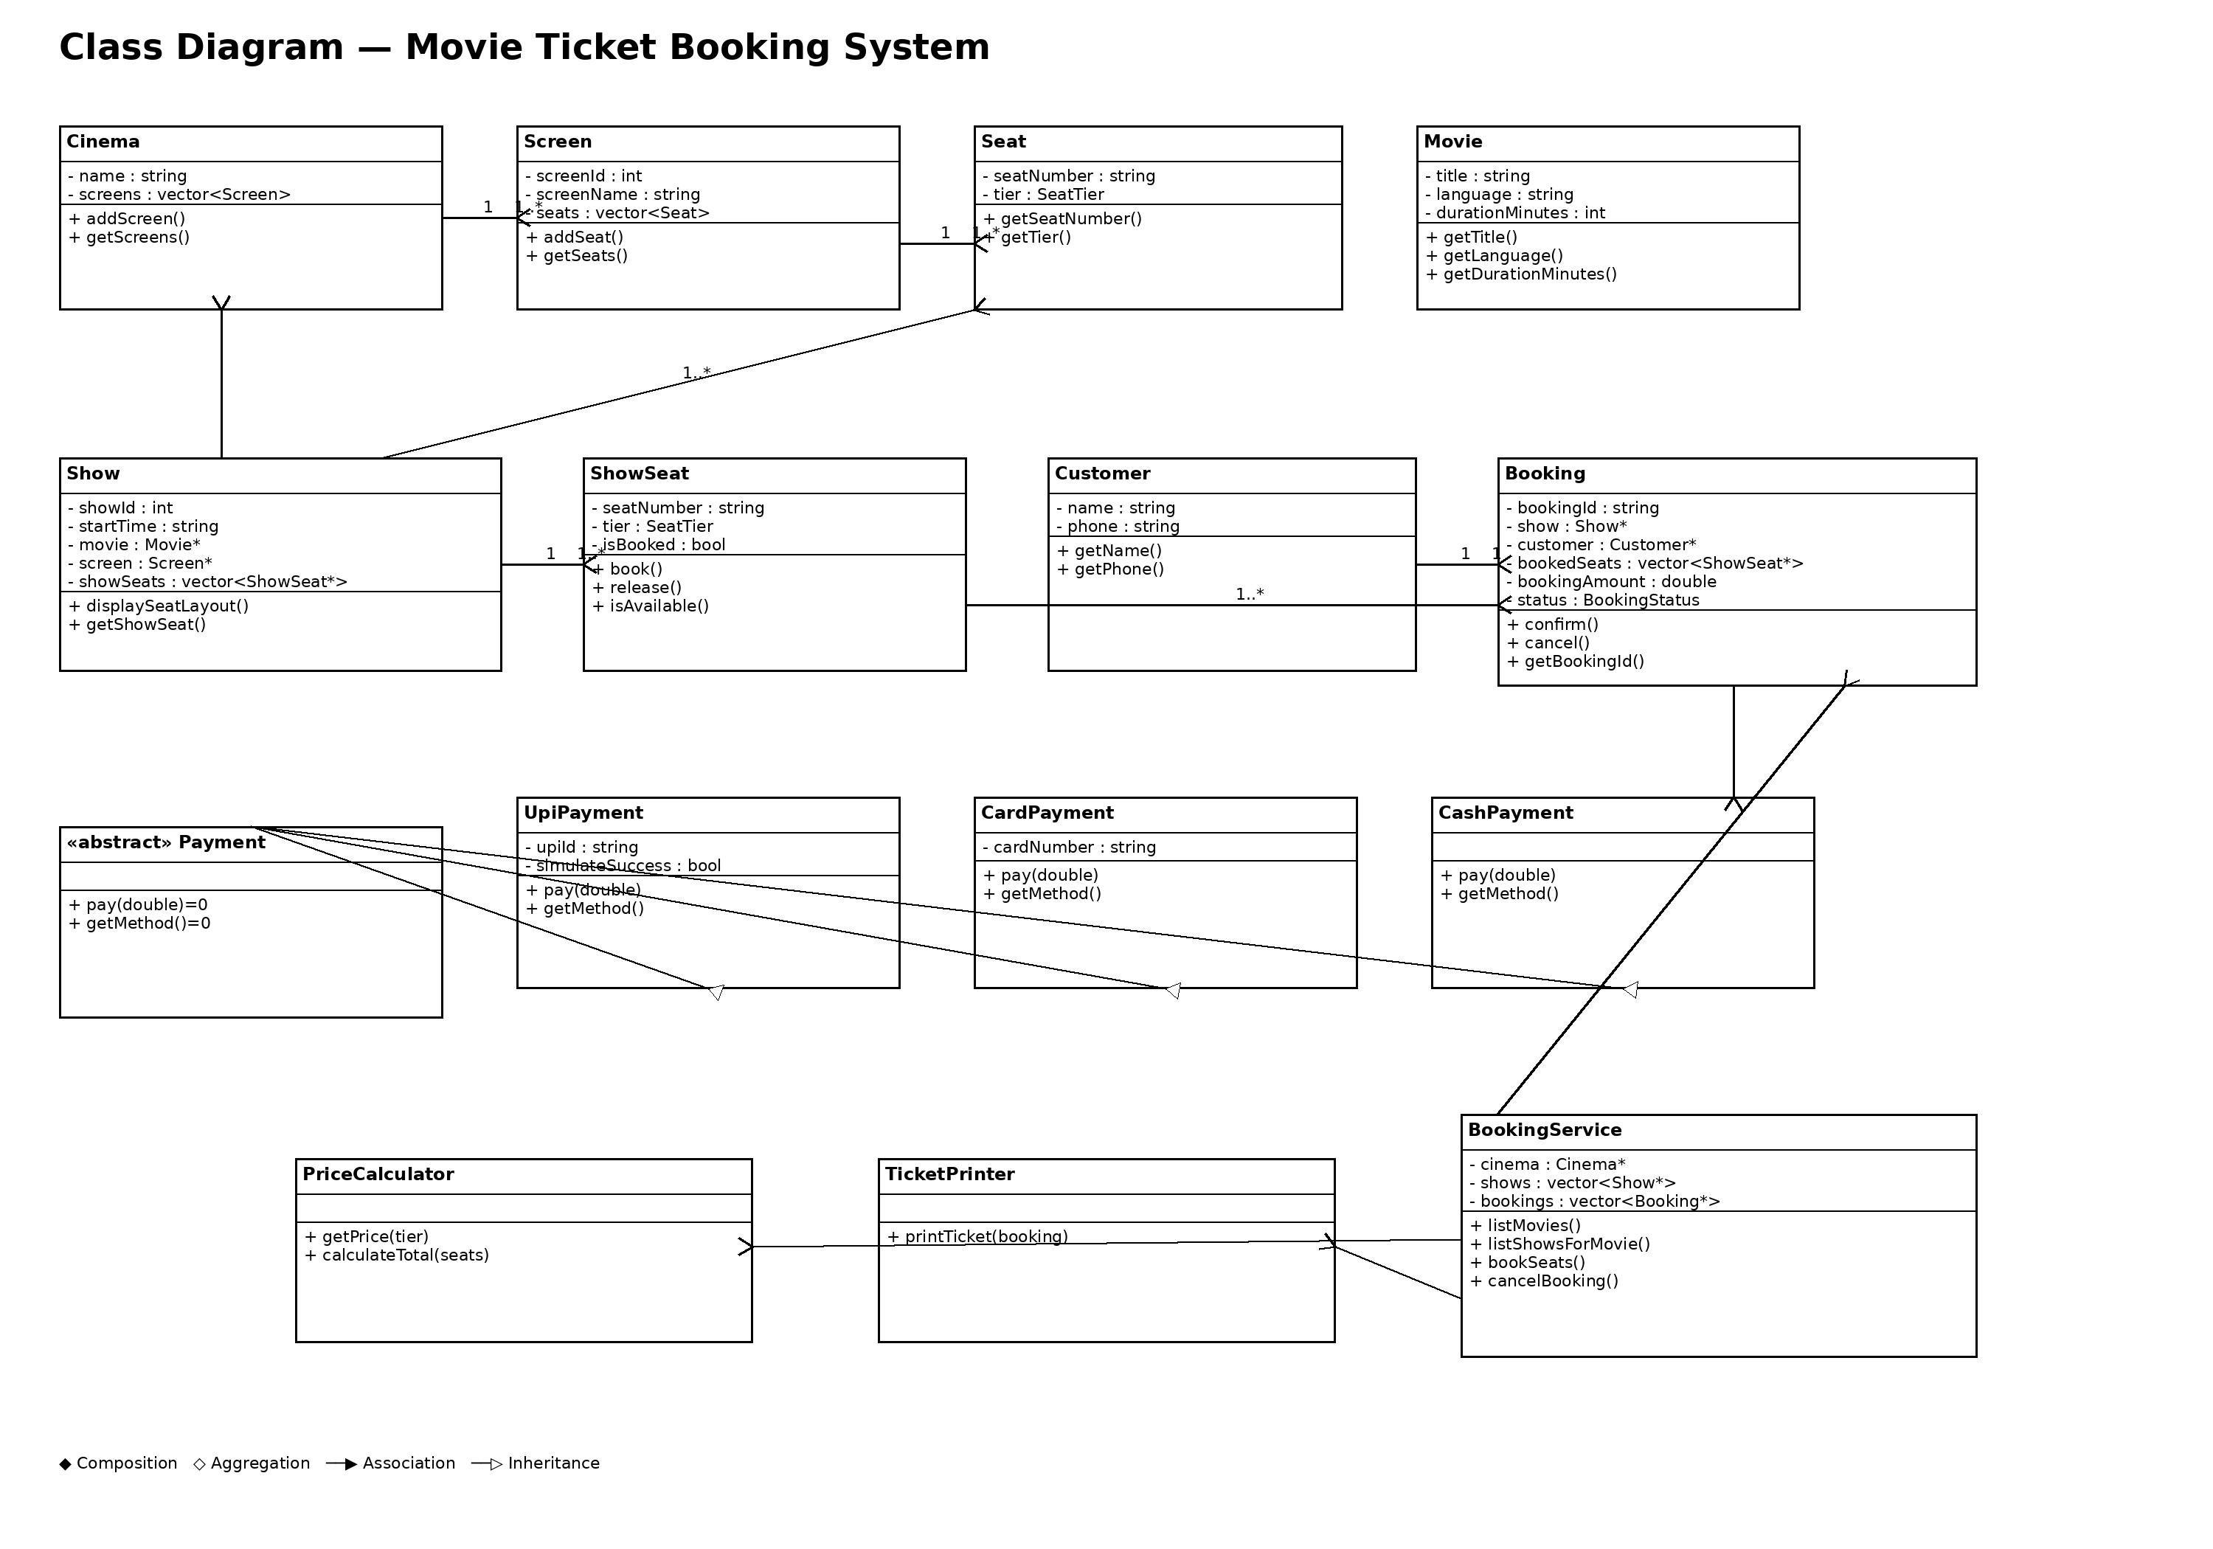

F. Sequence Diagram
Use case: customer books one seat and pays by UPI.
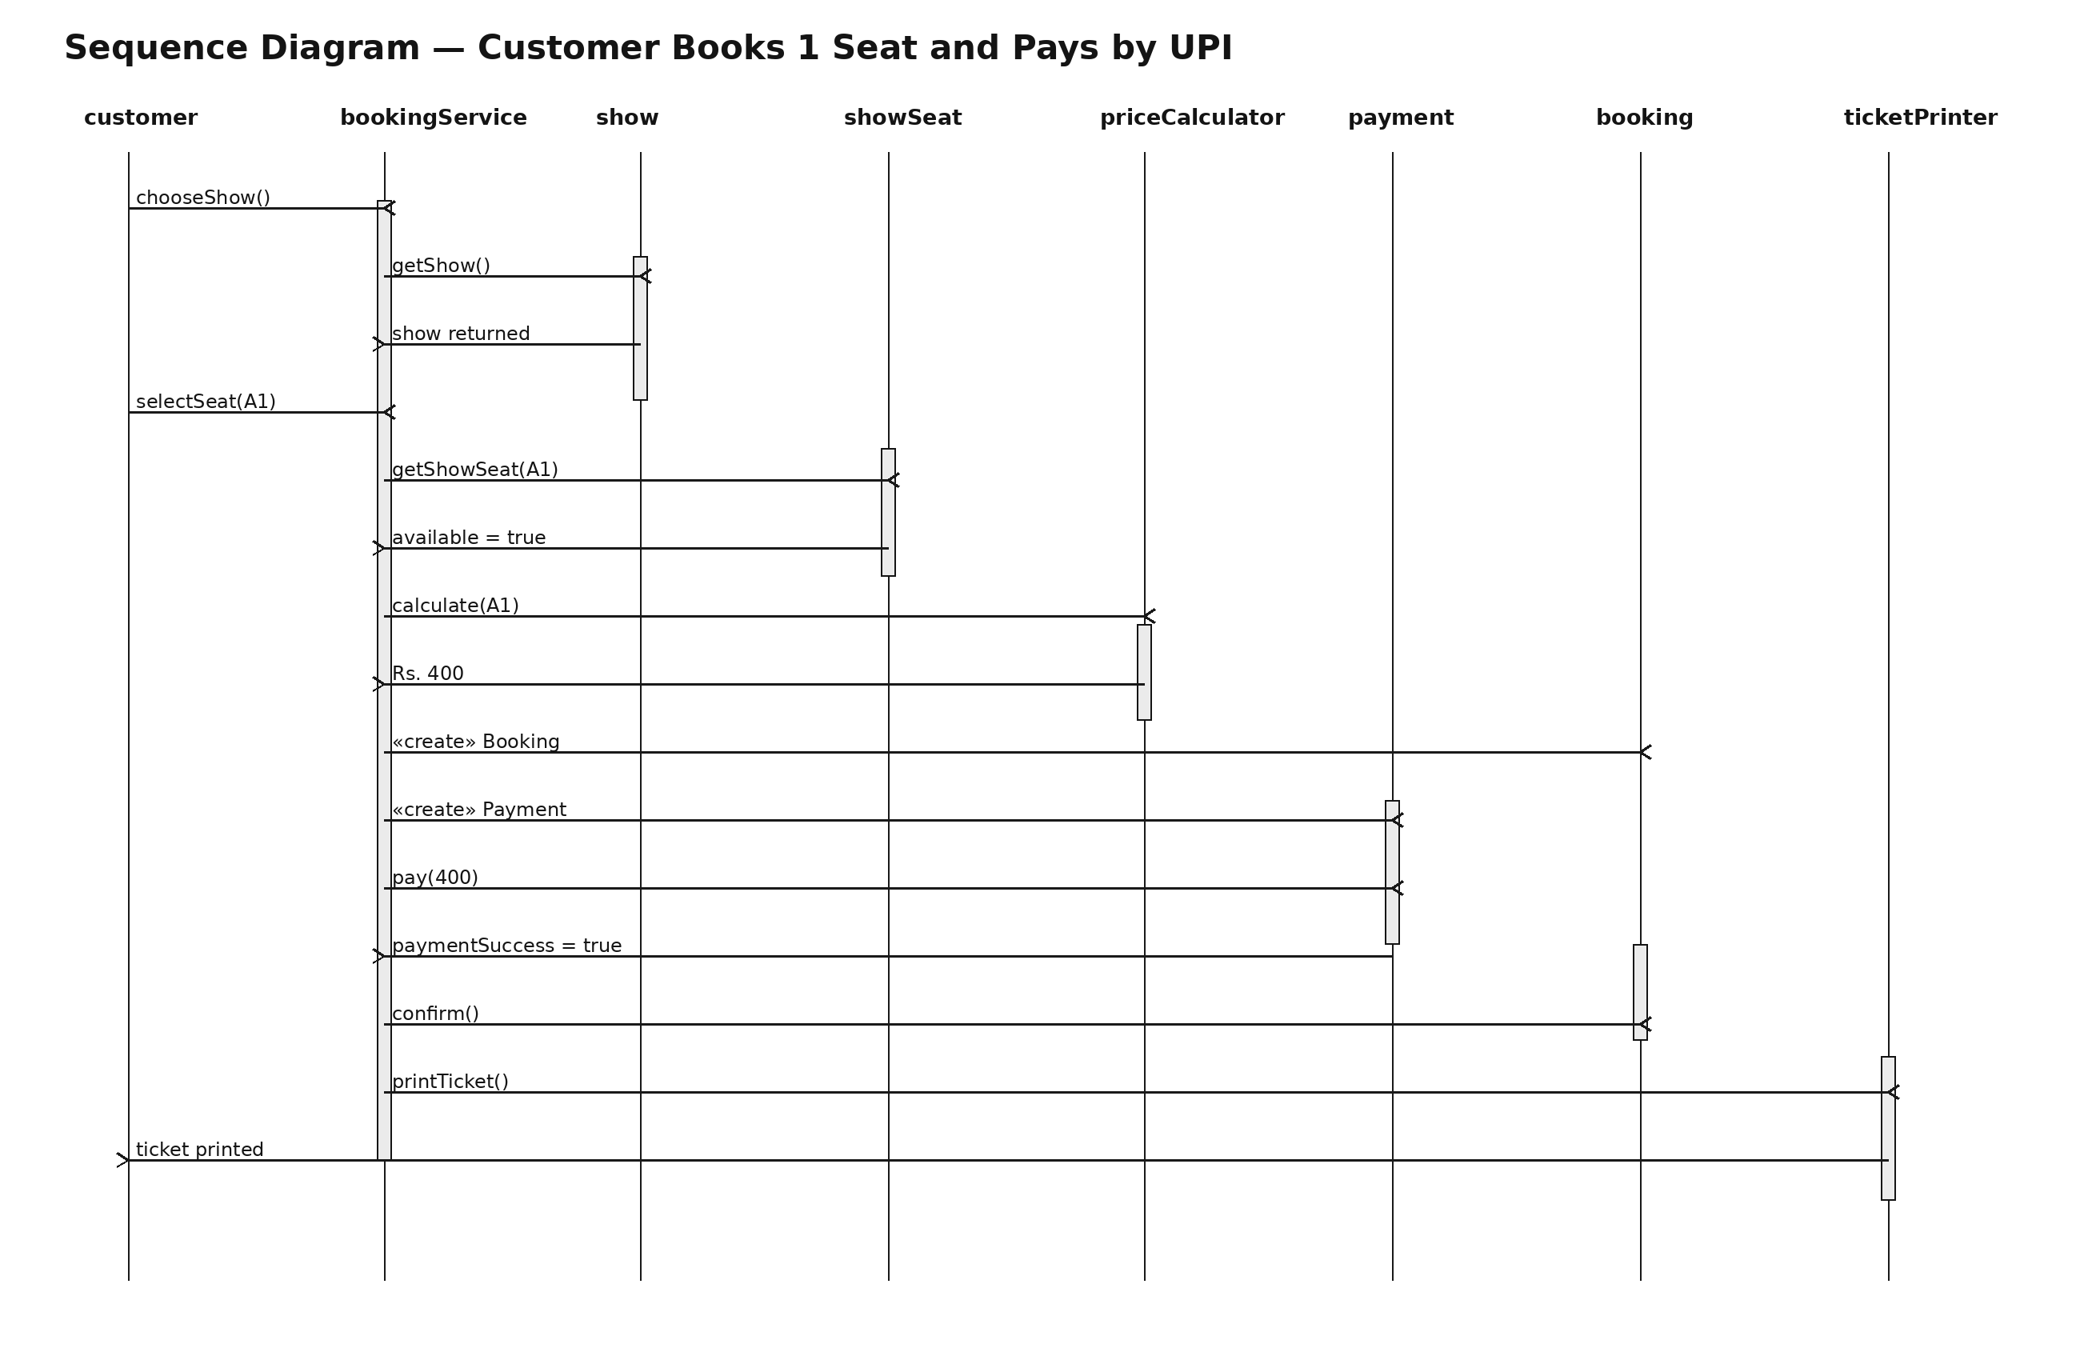

F. Modular Working Code + Demo Run
The working source is supplied in the accompanying folder named bookmyshow_project. It contains one class per source file and no header files. main.cpp includes the modules and provides the menu-driven console application.
- _Booking.cpp
- _BookingService.cpp
- _CardPayment.cpp
- _CashPayment.cpp
- _Cinema.cpp
- _Customer.cpp
- _Movie.cpp
- _Payment.cpp
- _PriceCalculator.cpp
- _Screen.cpp
- _Seat.cpp
- _Show.cpp
- _ShowSeat.cpp
- _TicketPrinter.cpp
- _UpiPayment.cpp
- main.cpp
The executable main.exe is also included in the folder after a successful C++17 build.

OOP concepts used
- Encapsulation — private data members and controlled methods are used in Movie, Seat, Customer and ShowSeat.
- Abstraction — Payment is an abstract class with pure virtual pay().
- Inheritance — UpiPayment, CardPayment and CashPayment derive from Payment.
- Runtime polymorphism — a Payment pointer/reference can invoke the overridden payment implementation.
- Compile-time polymorphism — overloaded Movie constructors and overloaded PriceCalculator methods are used.
- Static member — Booking::nextBookingId generates unique booking IDs.
- this keyword — constructors use this to refer to the current object.
- Composition — Cinema→Screen, Screen→Seat and Show→ShowSeat.
- Aggregation — Show→Movie and Booking→ShowSeat are represented as non-owning references.
- Association — Customer interacts with BookingService without ownership.

Demo evidence
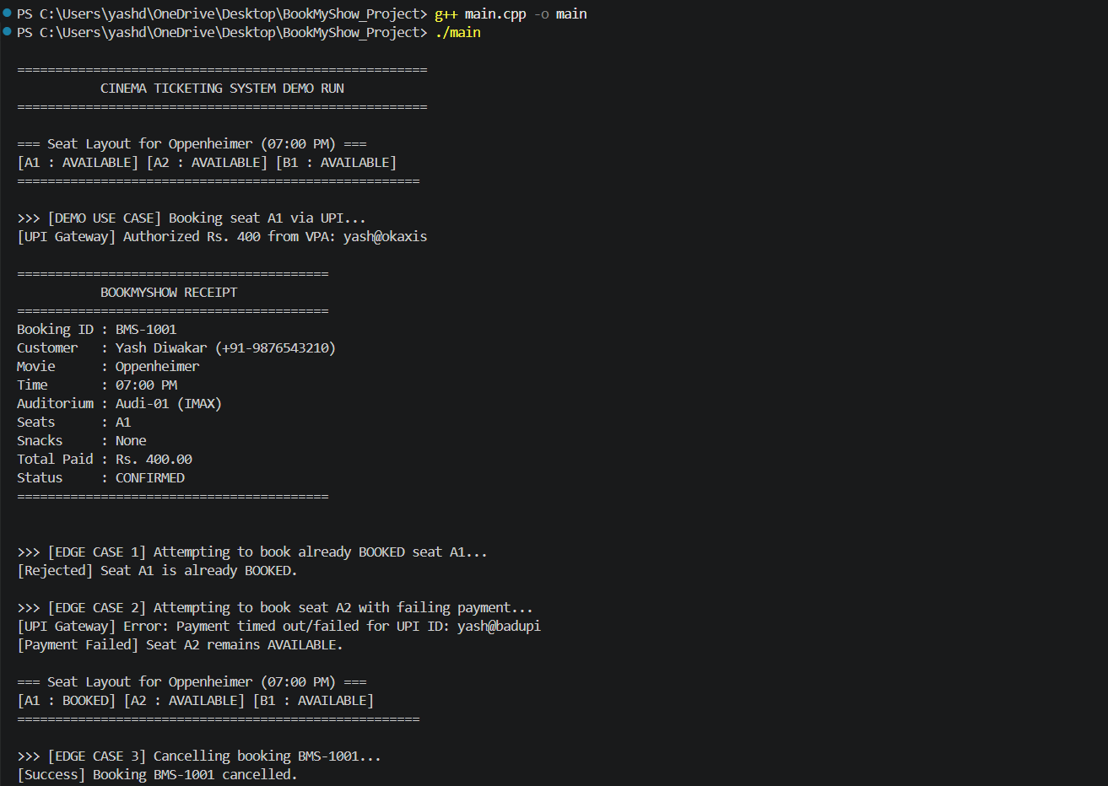
Submitted project demo screenshot.
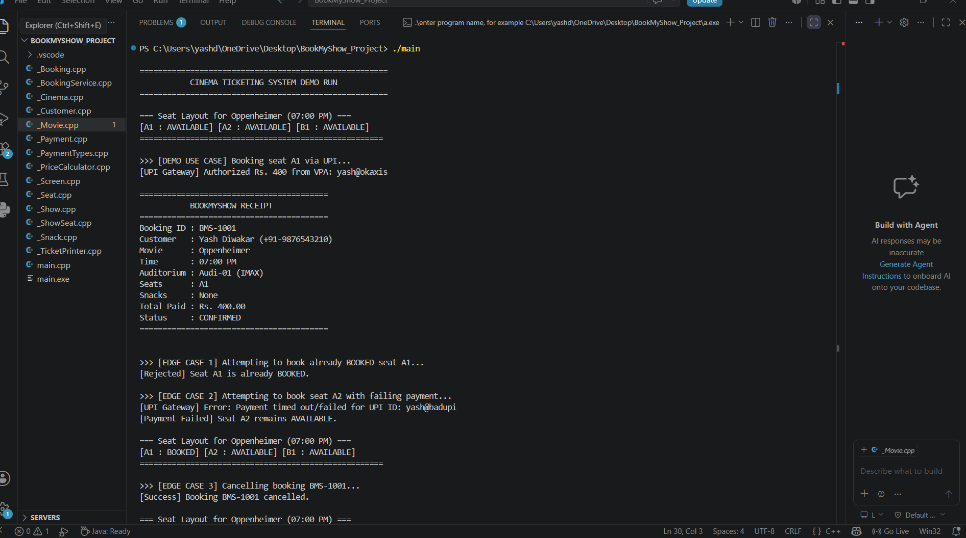
Submitted project demo screenshot.
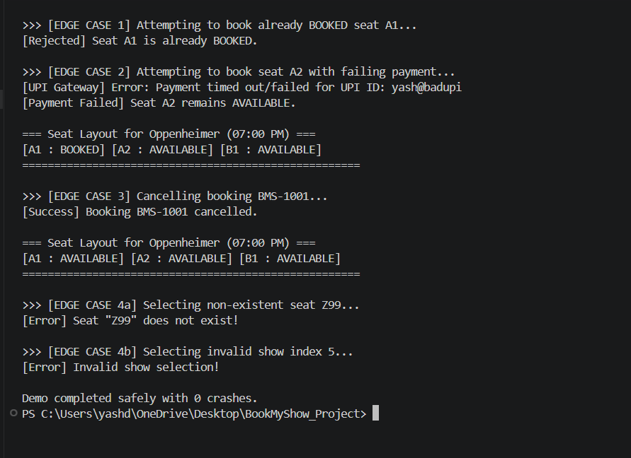
Submitted project demo screenshot.

Required edge cases
- Already BOOKED seat → booking rejected and the booked seat remains unchanged.
- Failed payment → booking is not confirmed and the selected seat remains AVAILABLE.
- Cancellation → confirmed booking becomes CANCELLED and its seats become AVAILABLE.
- Invalid seat number / show selection / menu choice → clear error message and no crash.

G. SOLID Mapping
S — Single Responsibility — Movie stores movie data, PriceCalculator calculates prices, TicketPrinter prints tickets and BookingService coordinates the workflow.
O — Open/Closed — A new payment type can be introduced as another Payment subclass without changing existing UPI/Card/Cash implementations.
L — Liskov Substitution — UpiPayment, CardPayment and CashPayment can be used wherever the Payment abstraction is expected.
I — Interface Segregation — The Payment abstraction exposes only the operations common to payment methods; unrelated operations are not forced on subclasses.
D — Dependency Inversion — BookingService receives a Payment abstraction rather than depending on a concrete payment implementation.

One thing deliberately not done
A database layer was not added because the assignment is a small single-cinema console application. Data is kept in memory so the design stays focused on OOP, relationships and SOLID principles.

Clean Code Checklist Applied
- Meaningful names are used instead of number-series names.
- Functions have focused responsibilities.
- Magic prices are represented as named constants.
- Repeated booking and validation logic is centralized in BookingService.
- Invalid inputs are checked before performing state changes.
- Seat status is modified through book() and release() rather than direct public access.

